S3 TASK

Create an S3 bucket and upload some objects to S3
- Go to s3 in aws
- Then create s3 bucket
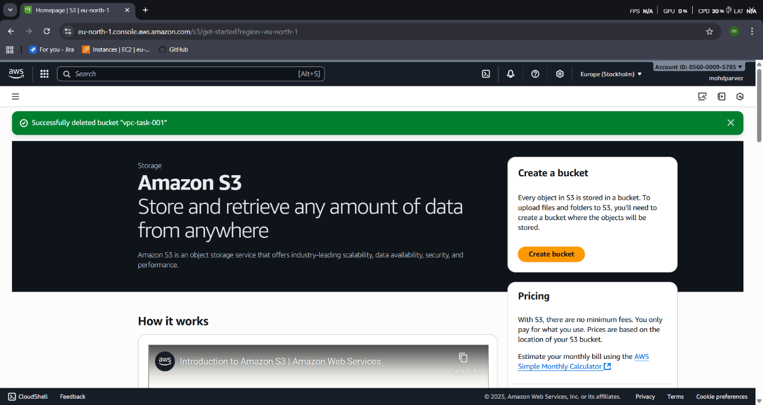
- Then select ACLs enable – slsect owner ship
- ACLs disabled :All objects in this bucket are owned by this account. Access to this bucket and its objects is specified using only policies.
- ACLs enabled: Objects in this bucket can be owned by other AWS accounts. Access to this bucket and its objects can be specified using ACLs.
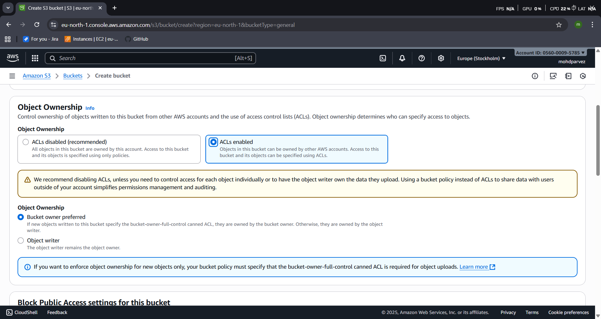

- Select block public option if you don’t want to acess the public.
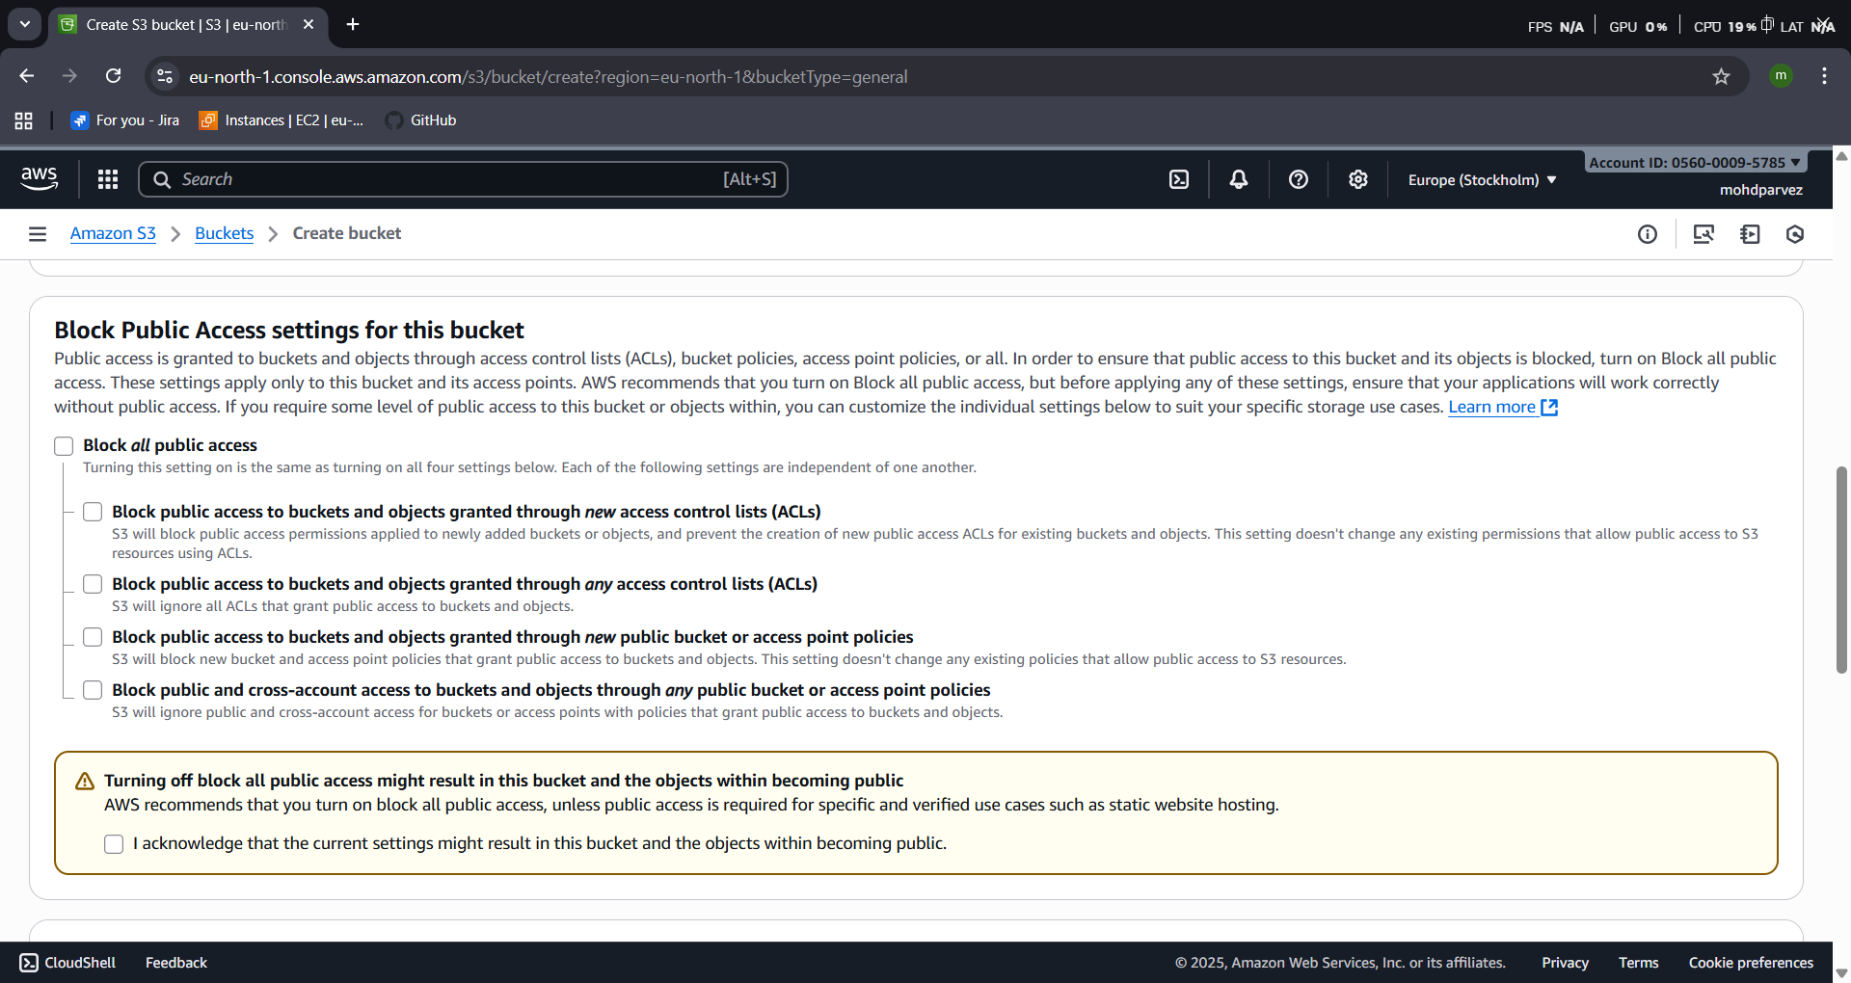
- Bucket versioning if you want the old files also need to stored after adding the neew content in new version of file and save the old version
- Then create bucket
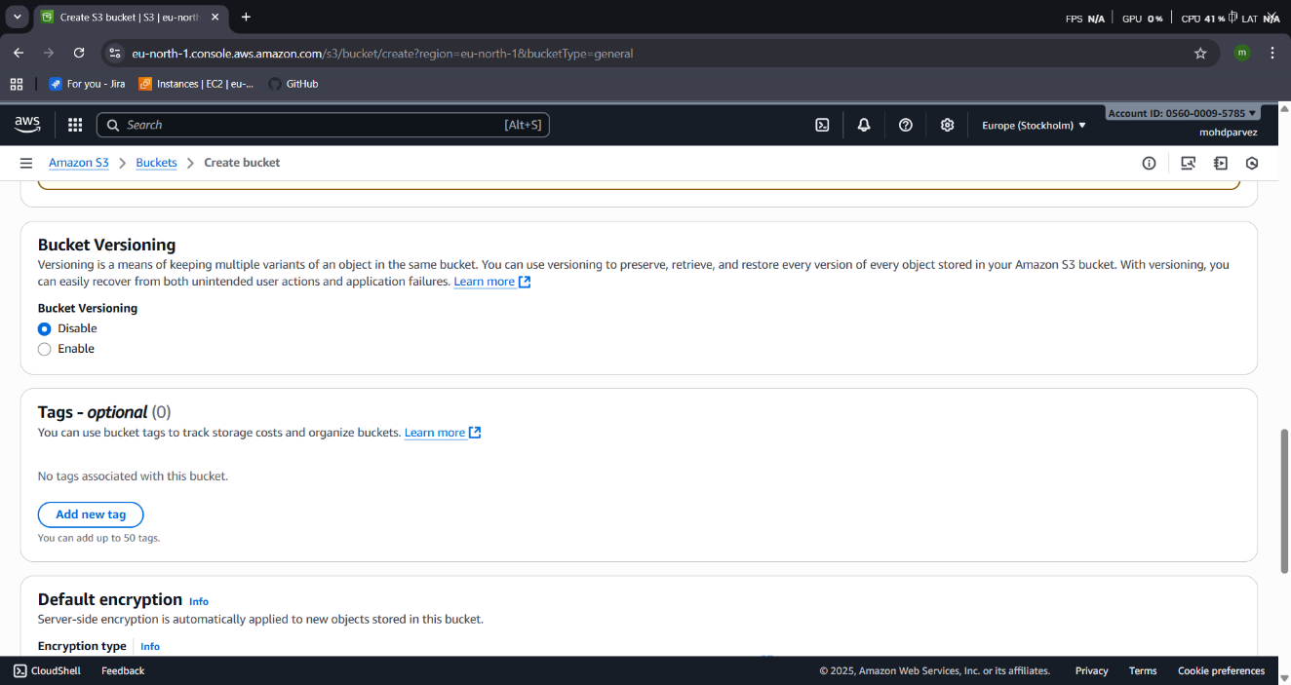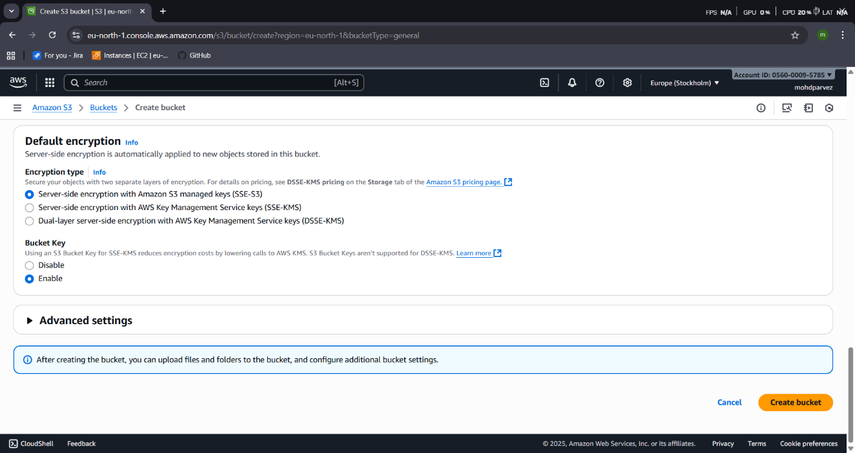
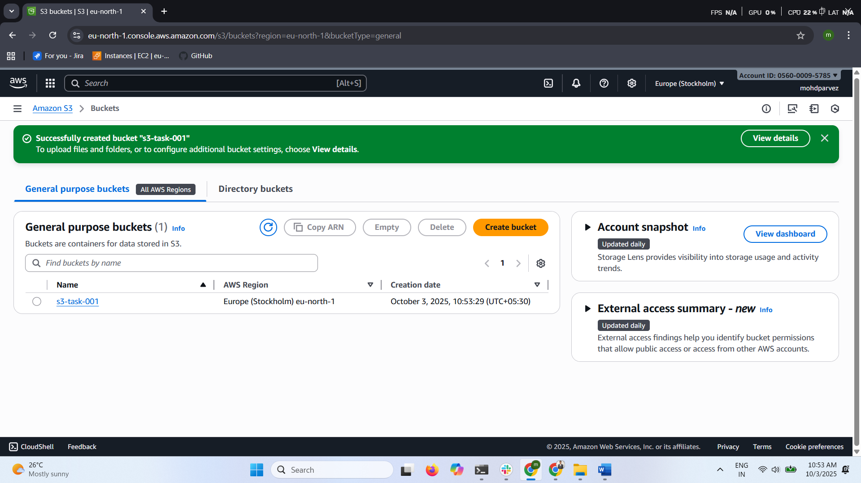
- Then got to your created bucket
- Upload – select the filles you want to upload
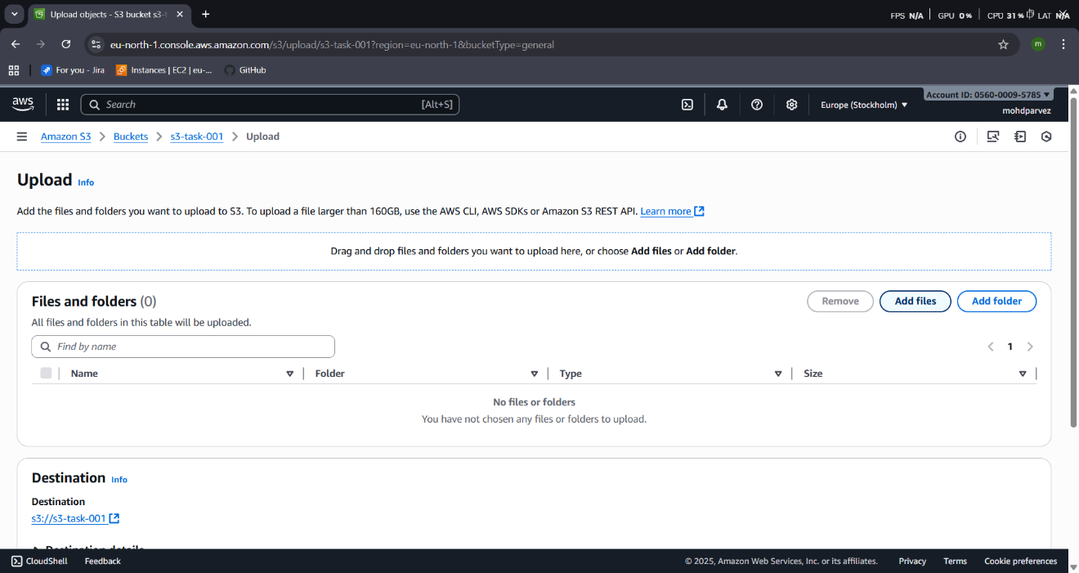
- Then files are uploaded to s3 bucket
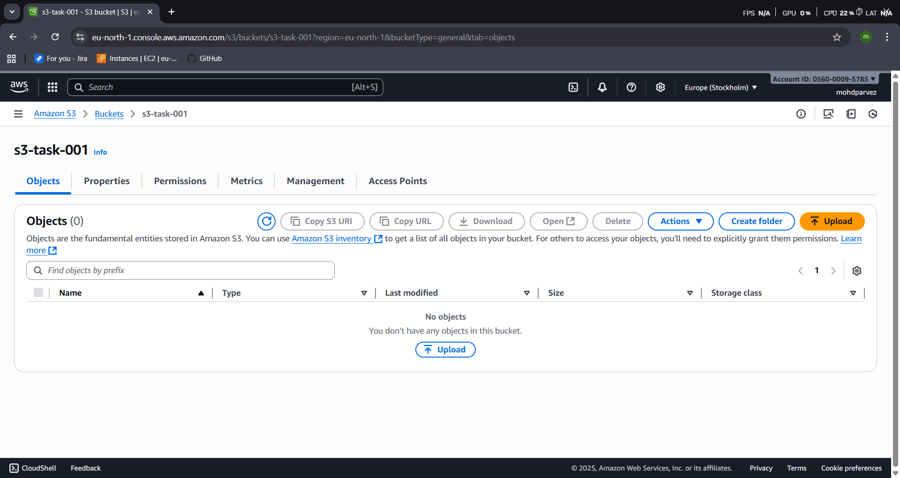
- Add files –select the files
- Select the permission to grant access the files public
- The file is successfully uploaded in the s3 bucket.

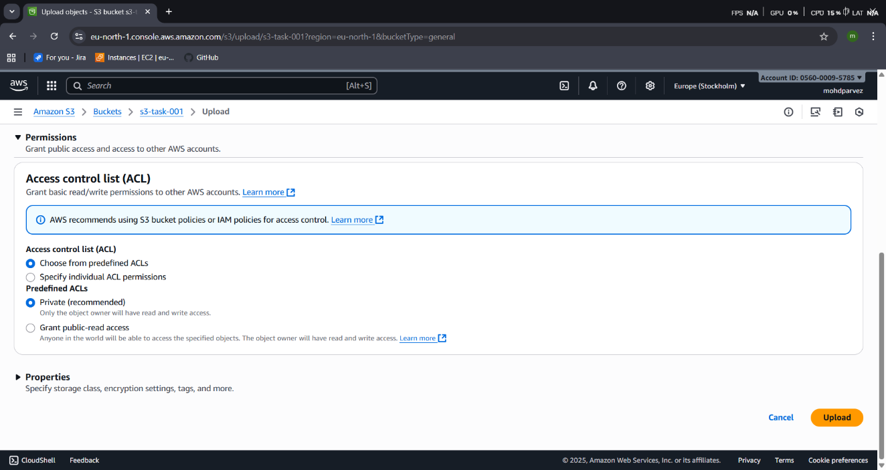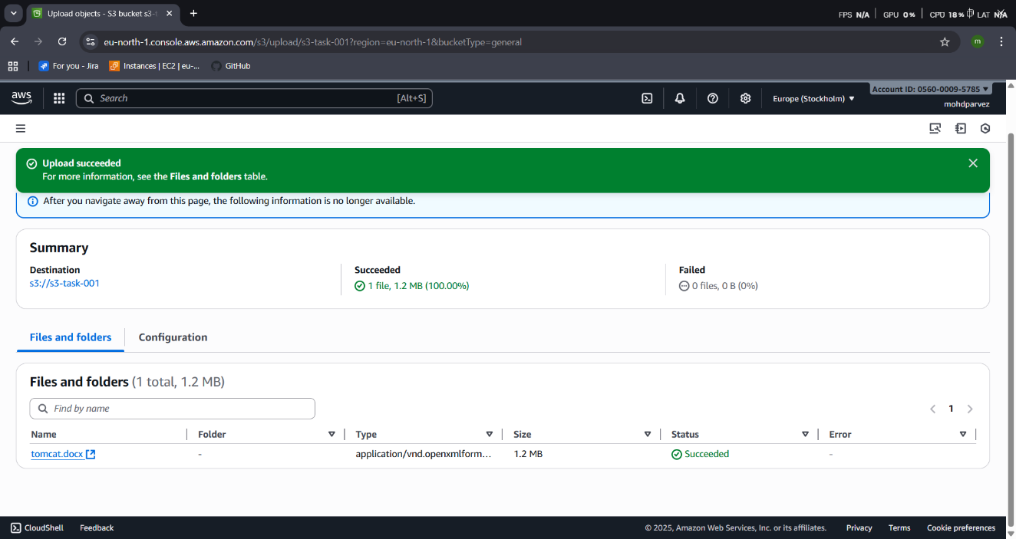

Deploy a static website in the S3 bucket.
- Go to your s3 bucket
- Properties -- enable static website – index.html
- Upload one html file and make sure your bucket has public acess if not ACLs enable in s3 configuration.
- Upload index.html and error.html file to lauch an static website
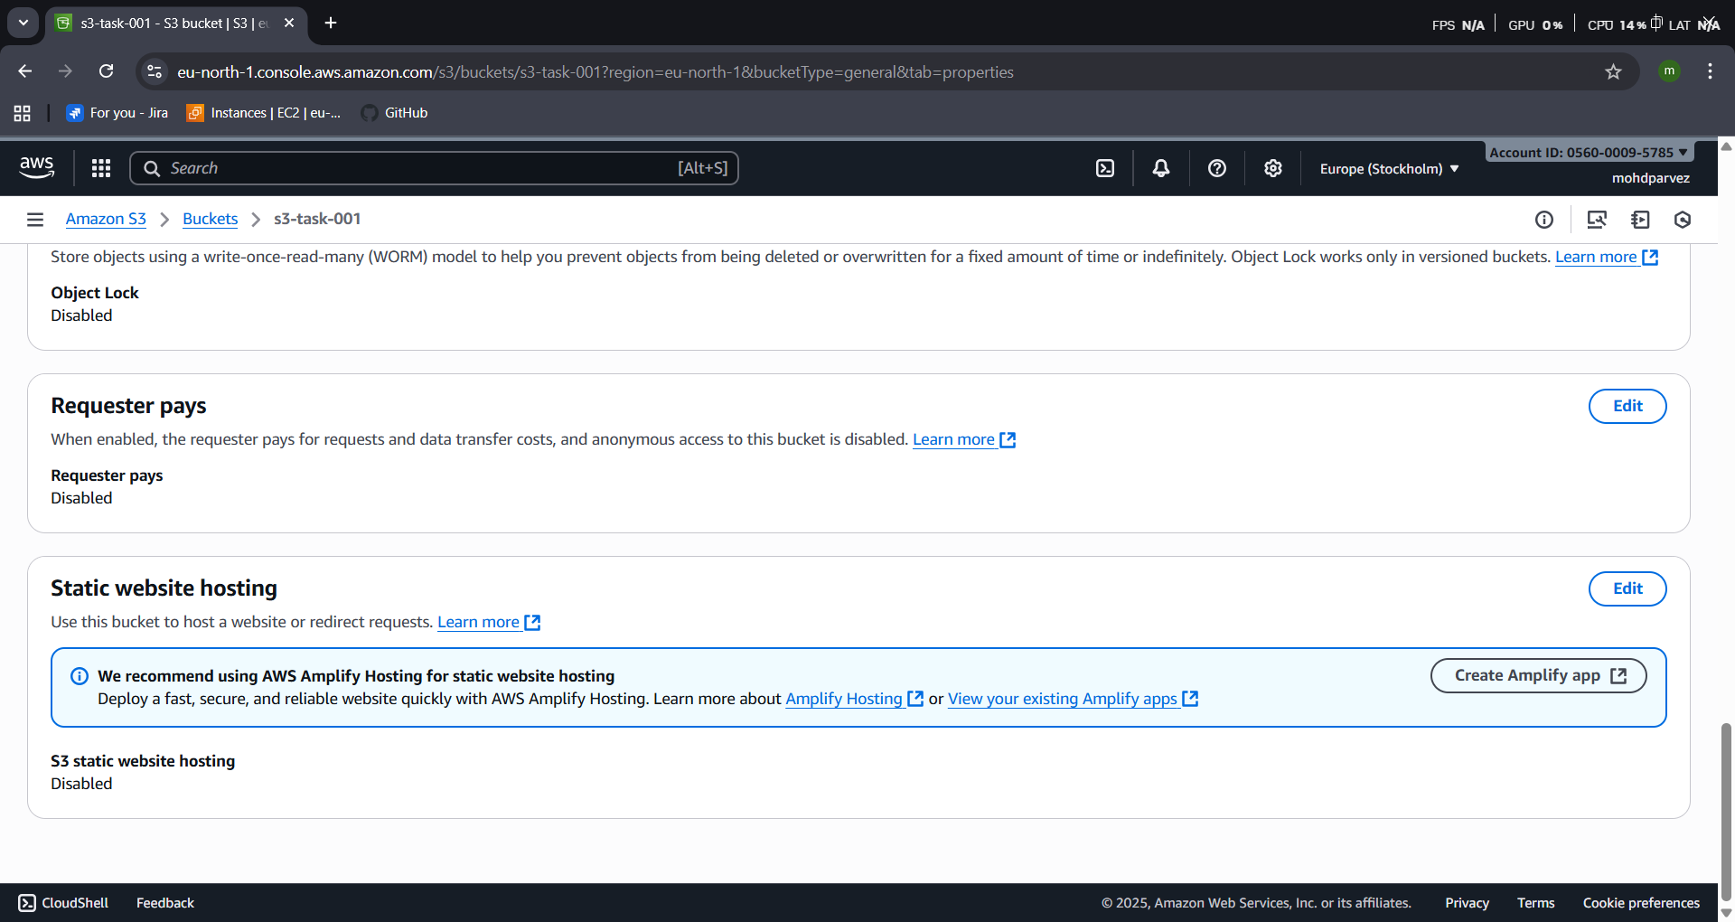
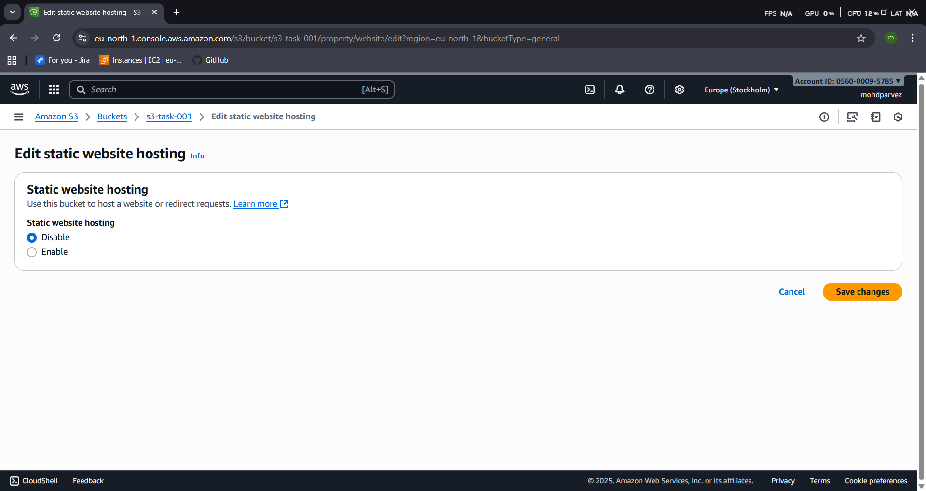
- Then go to bucket – properties – static website hosting
- Copy the url and paste it in the the browser to check.
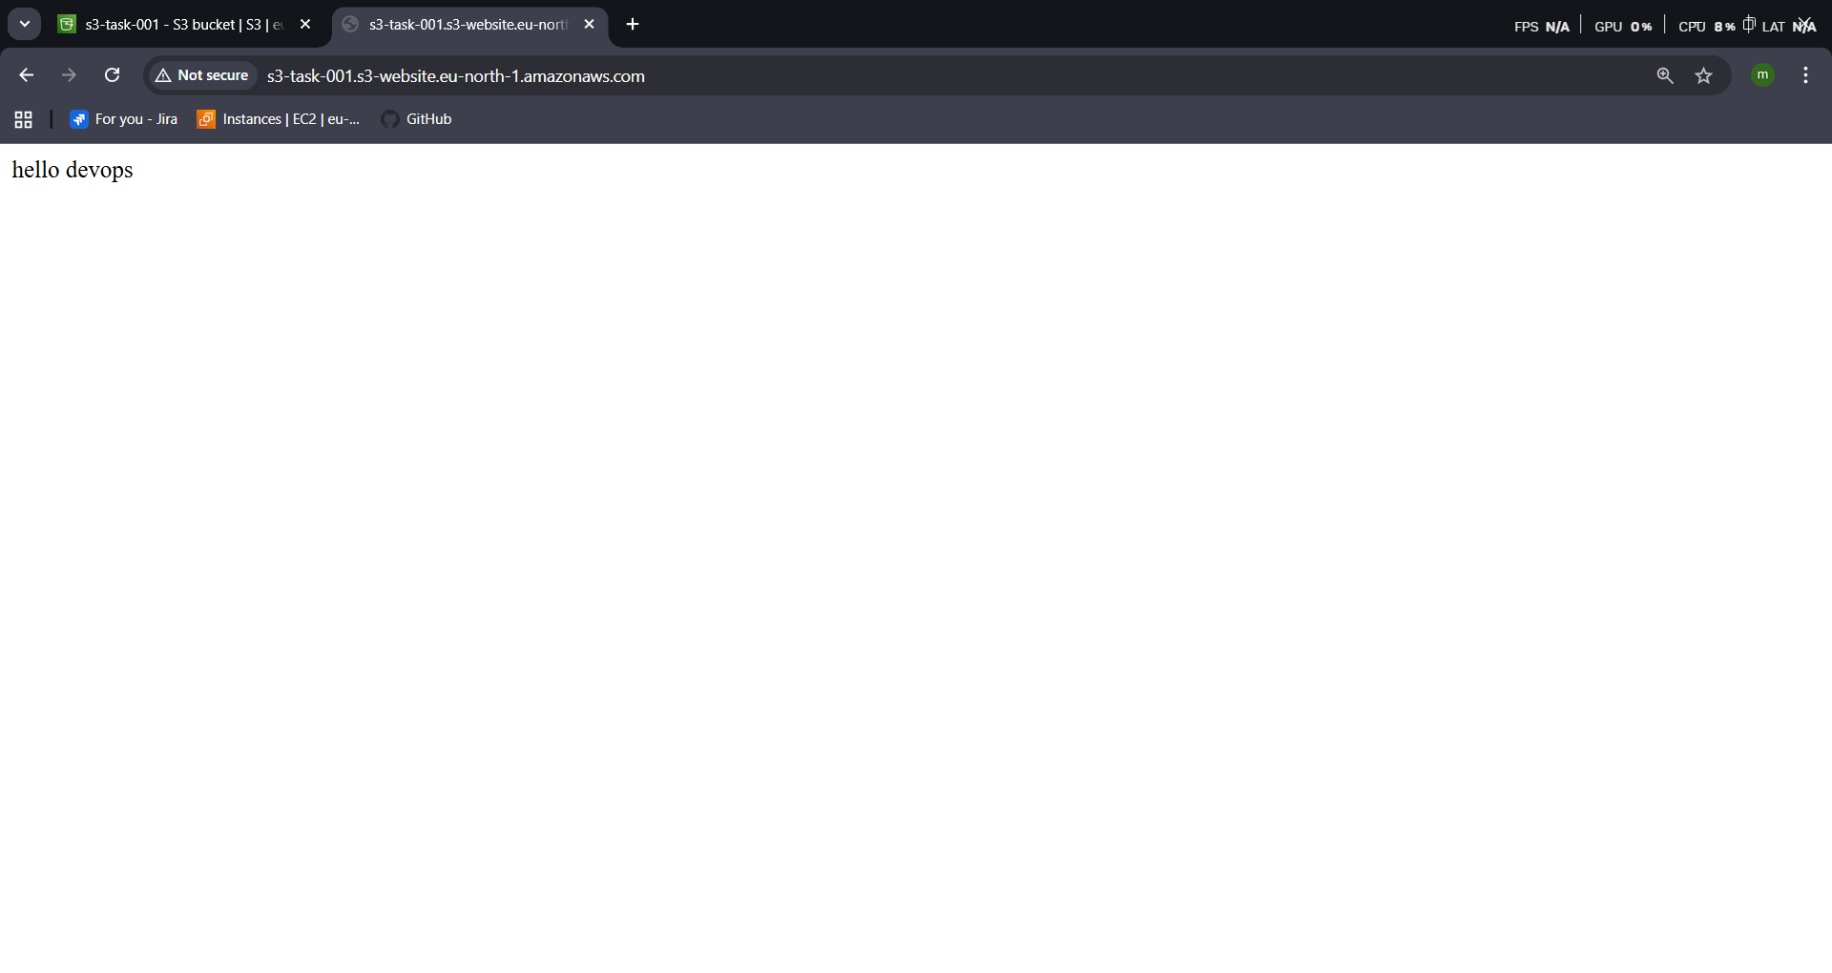
- Enable cross-region replication on S3 buckets.
- Create 2 buckets in two different region
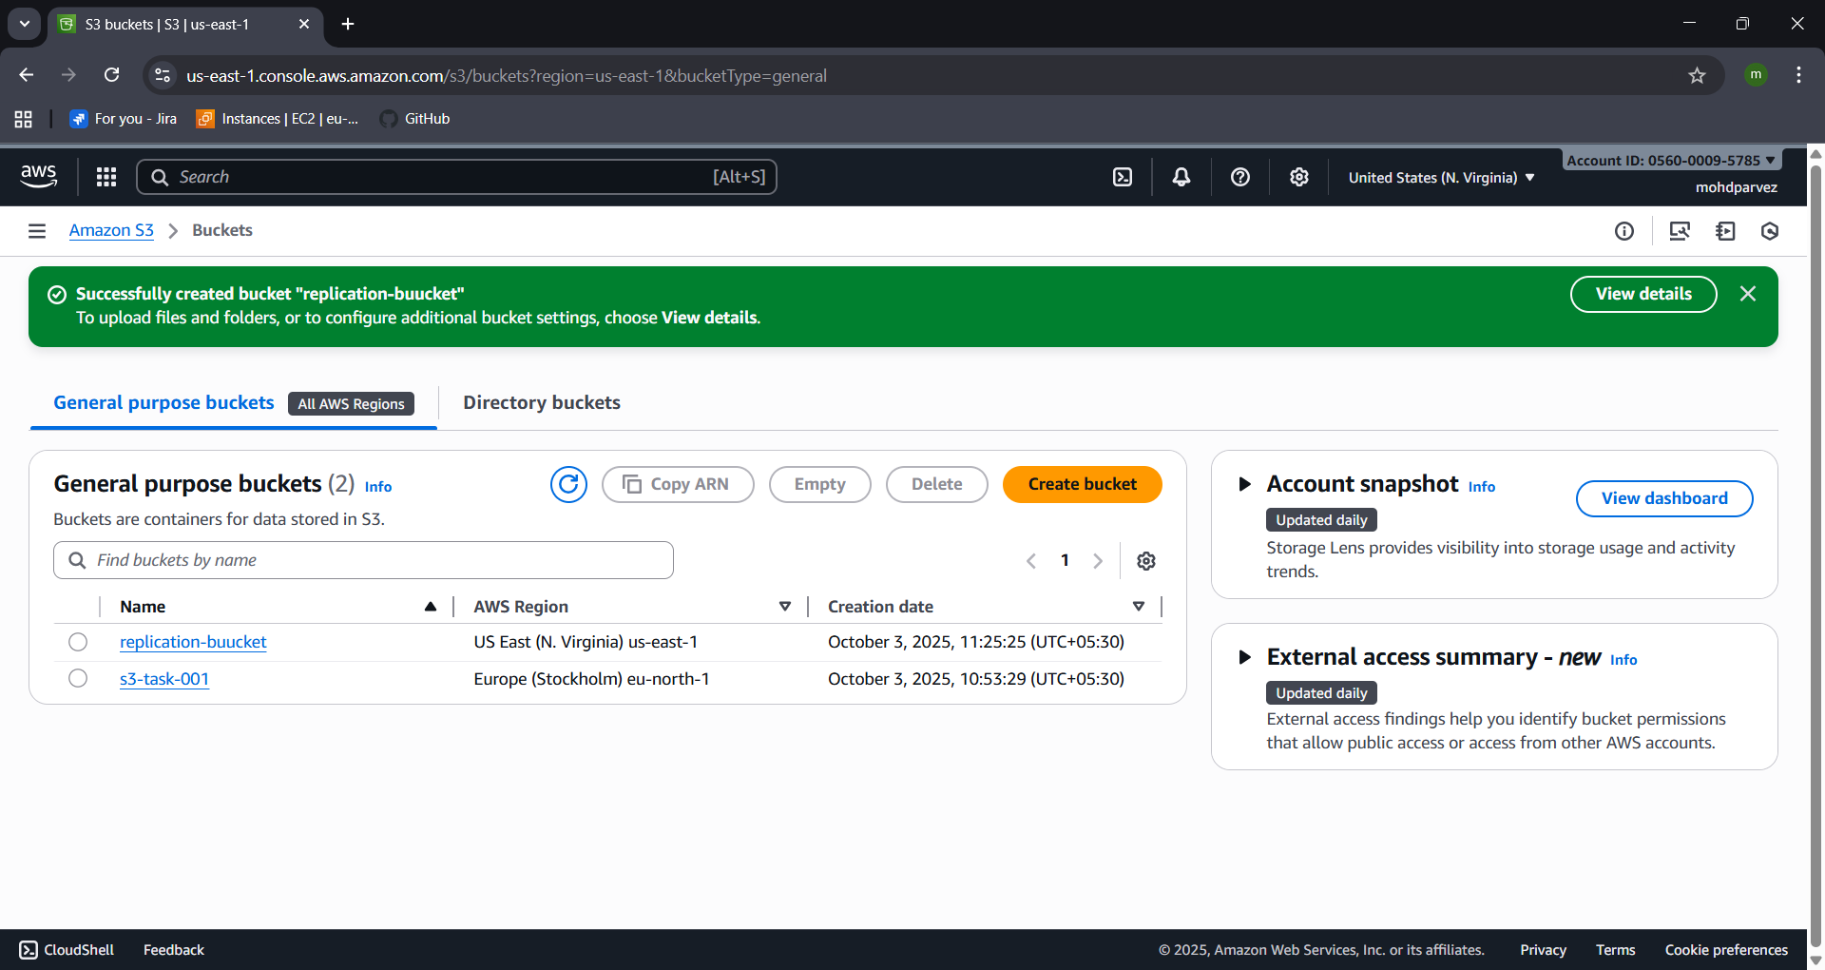
- Then go to iam create role with s3 fullacess.
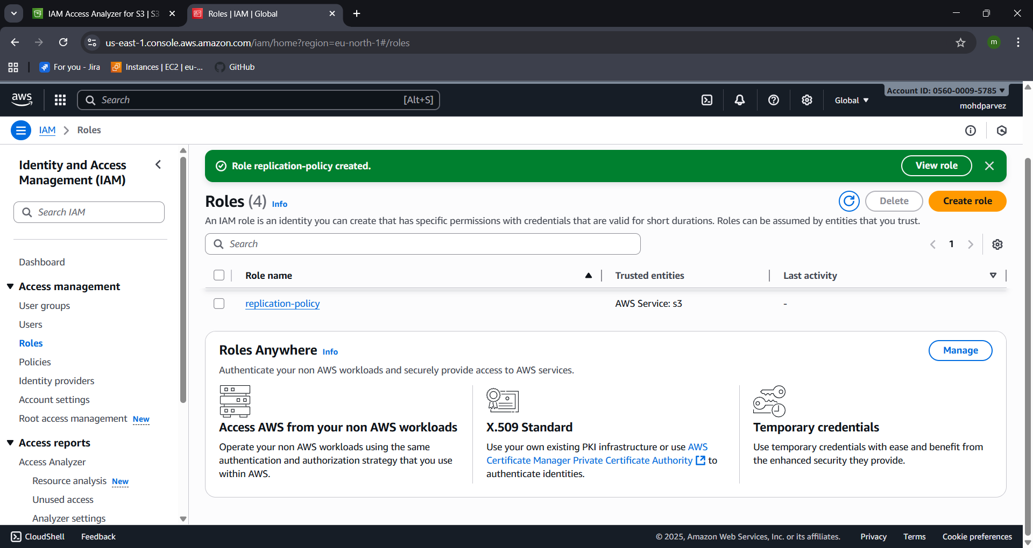
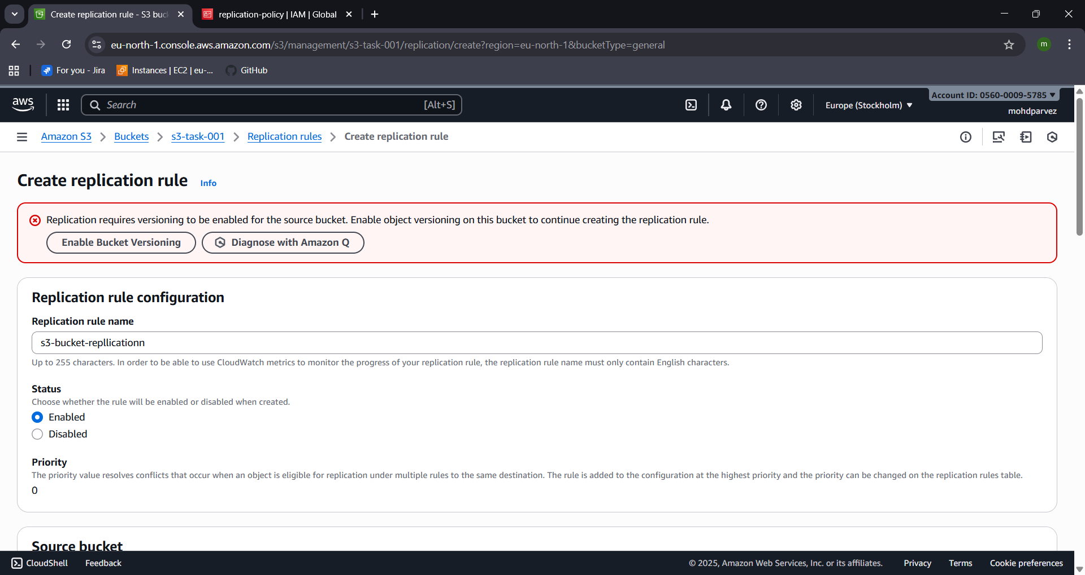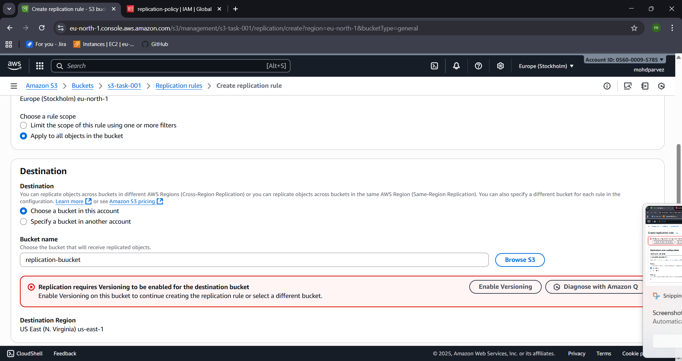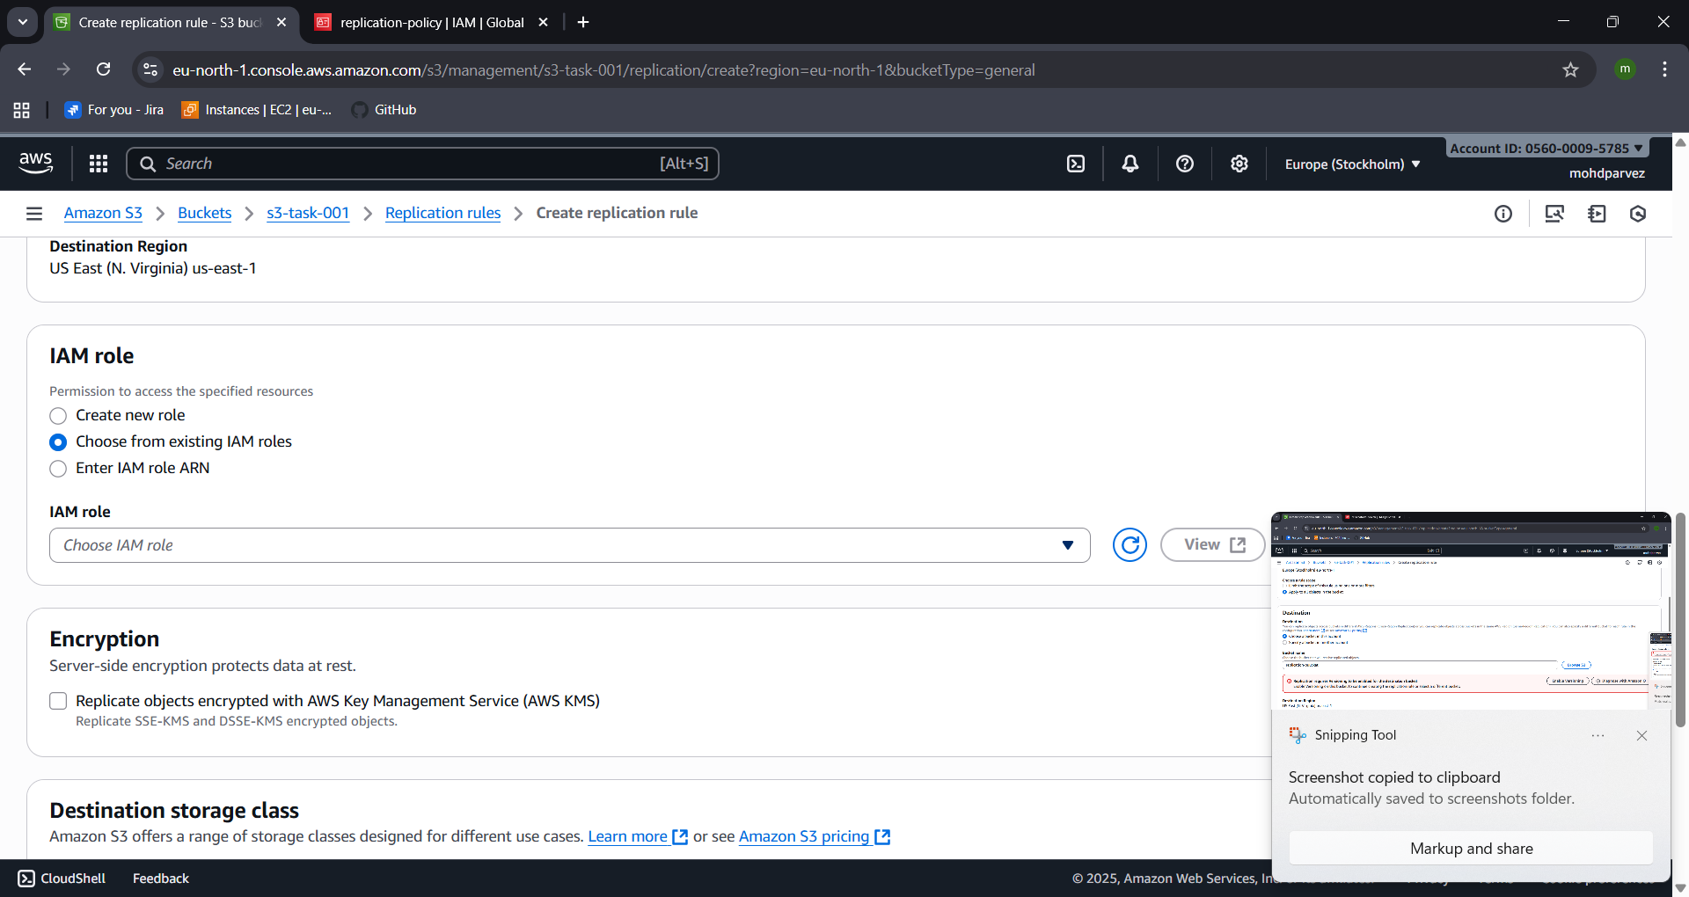
- Go to s3 –bucker – permissions
- Create the replication rule
- Select the source and destination then give permission to acess public using ACLs
- Create IAM role and attach policy for replication
- Then choose the iam role
- Then create the replication job
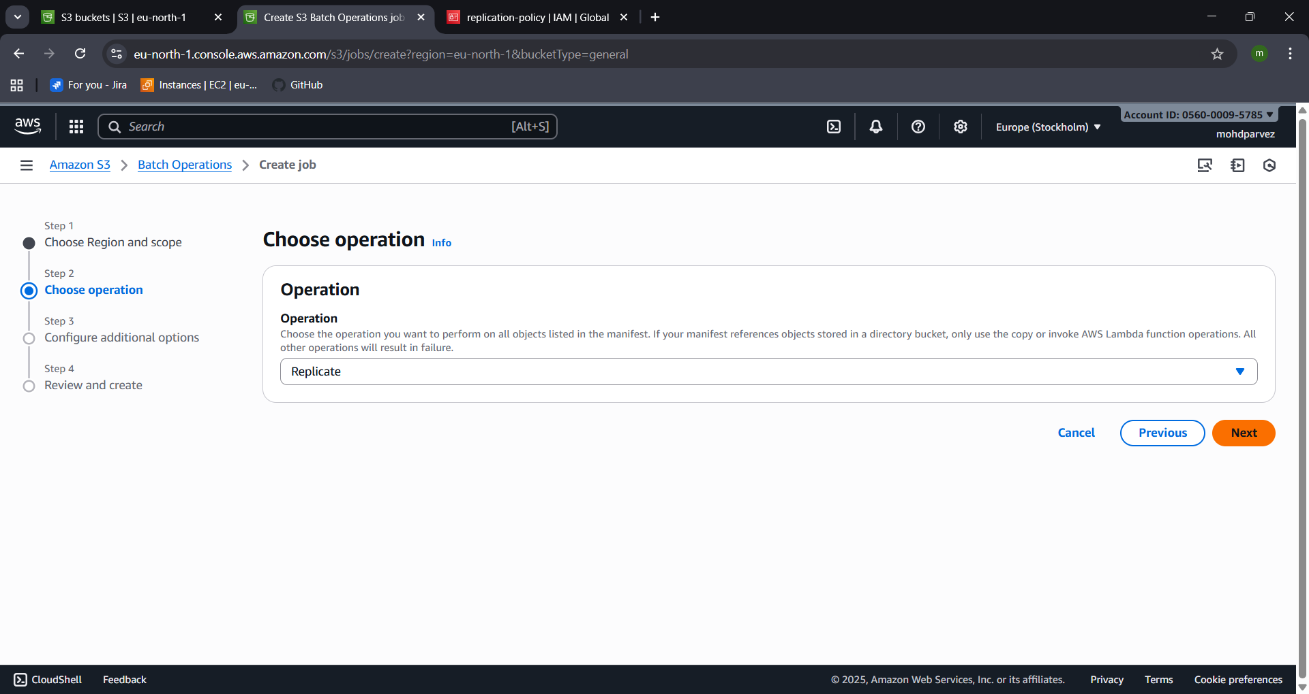
- Enable and run the job so the cross region replication is done

- CONFIGURE A BUCKET POLICY SO ONLY THE ADMIN USER CAN SEE THE OBJECTS OF THE S3 BUCKET.
- Go to aws s3 bucket
- Properties copy the arn
- Got browser search for aws policy generator

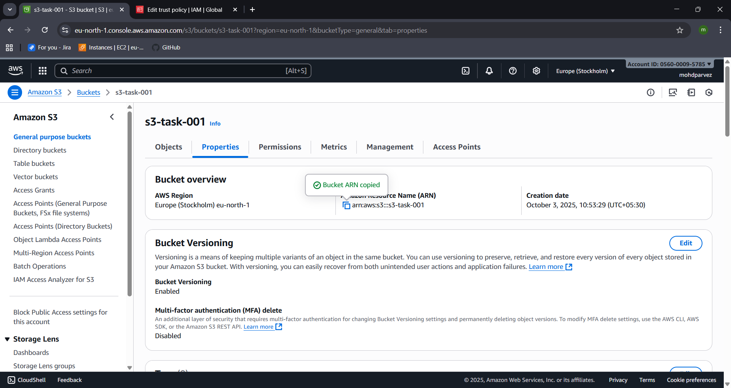

- Select the service and all actions
- Give the arn of the bucket
- Add statement – generate policy – copy the policy
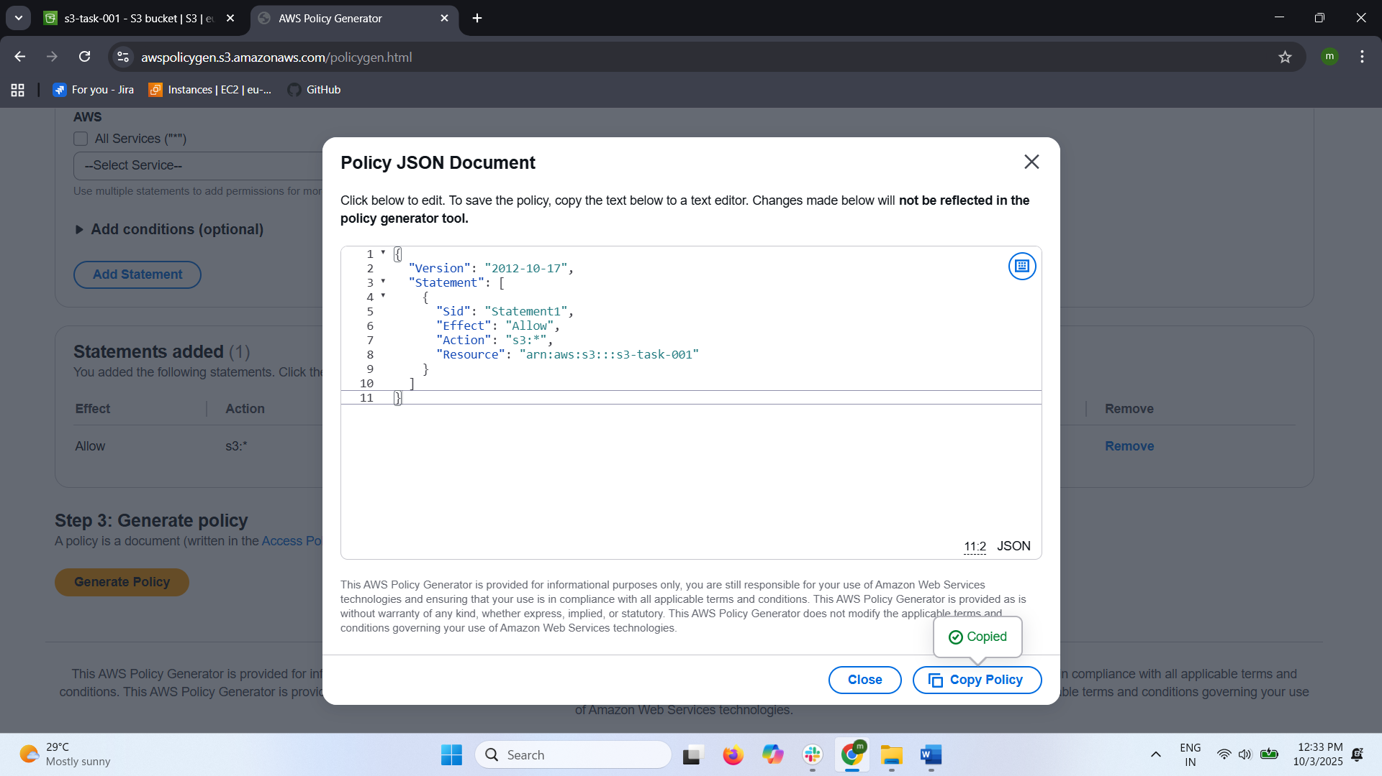
- Go to iam – create policy -- paste the policy --create the user
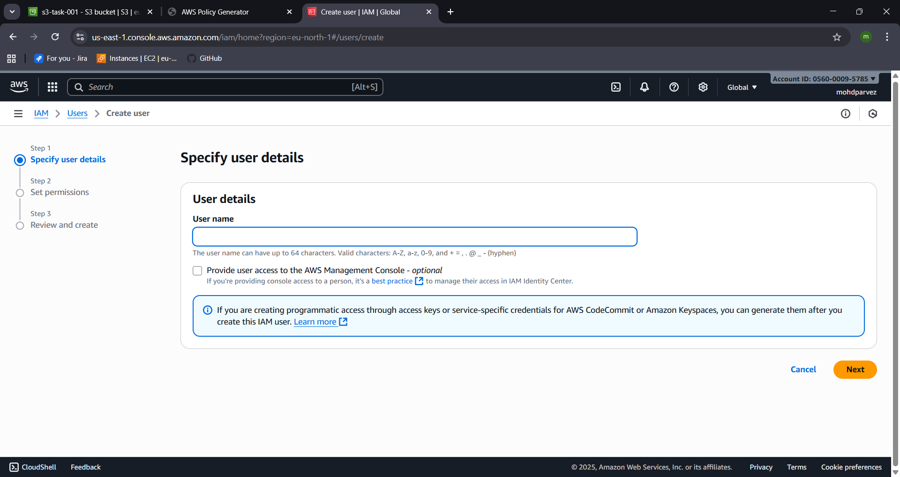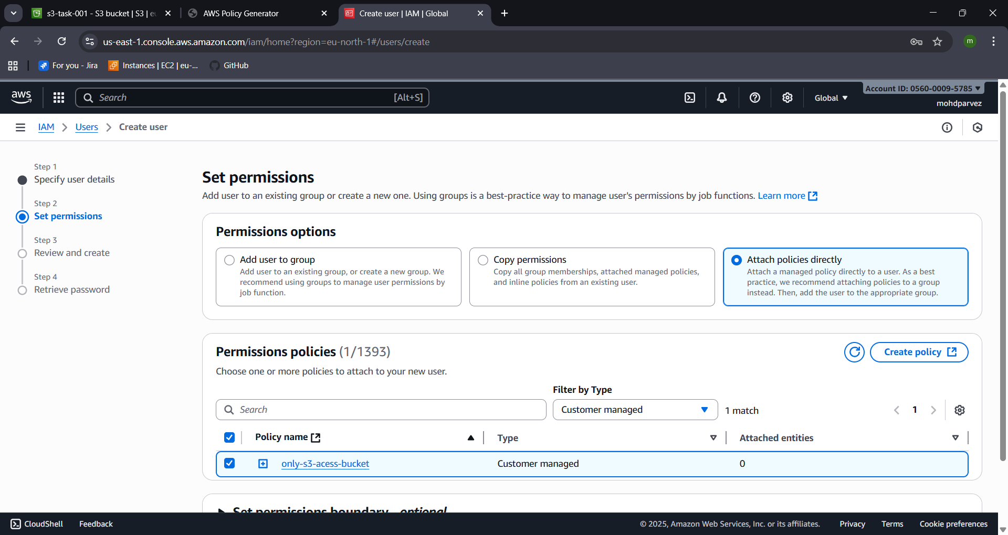

SET UP LIFECYCLE POLICIES TO AUTOMATICALLY TRANSITION OR DELETE OBJECTS BASED ON SPECIFIC CRITERIA.
- Go to s3 bucket – management --- create life cyclerule
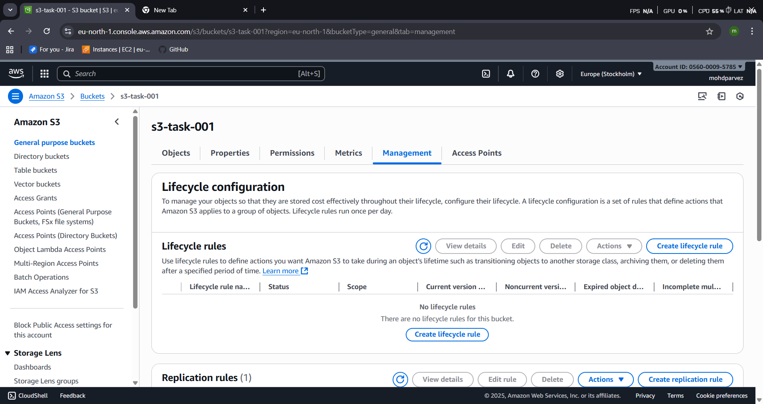
- Give the life cycle name and specify the criteria from the options life cycle rule actions.
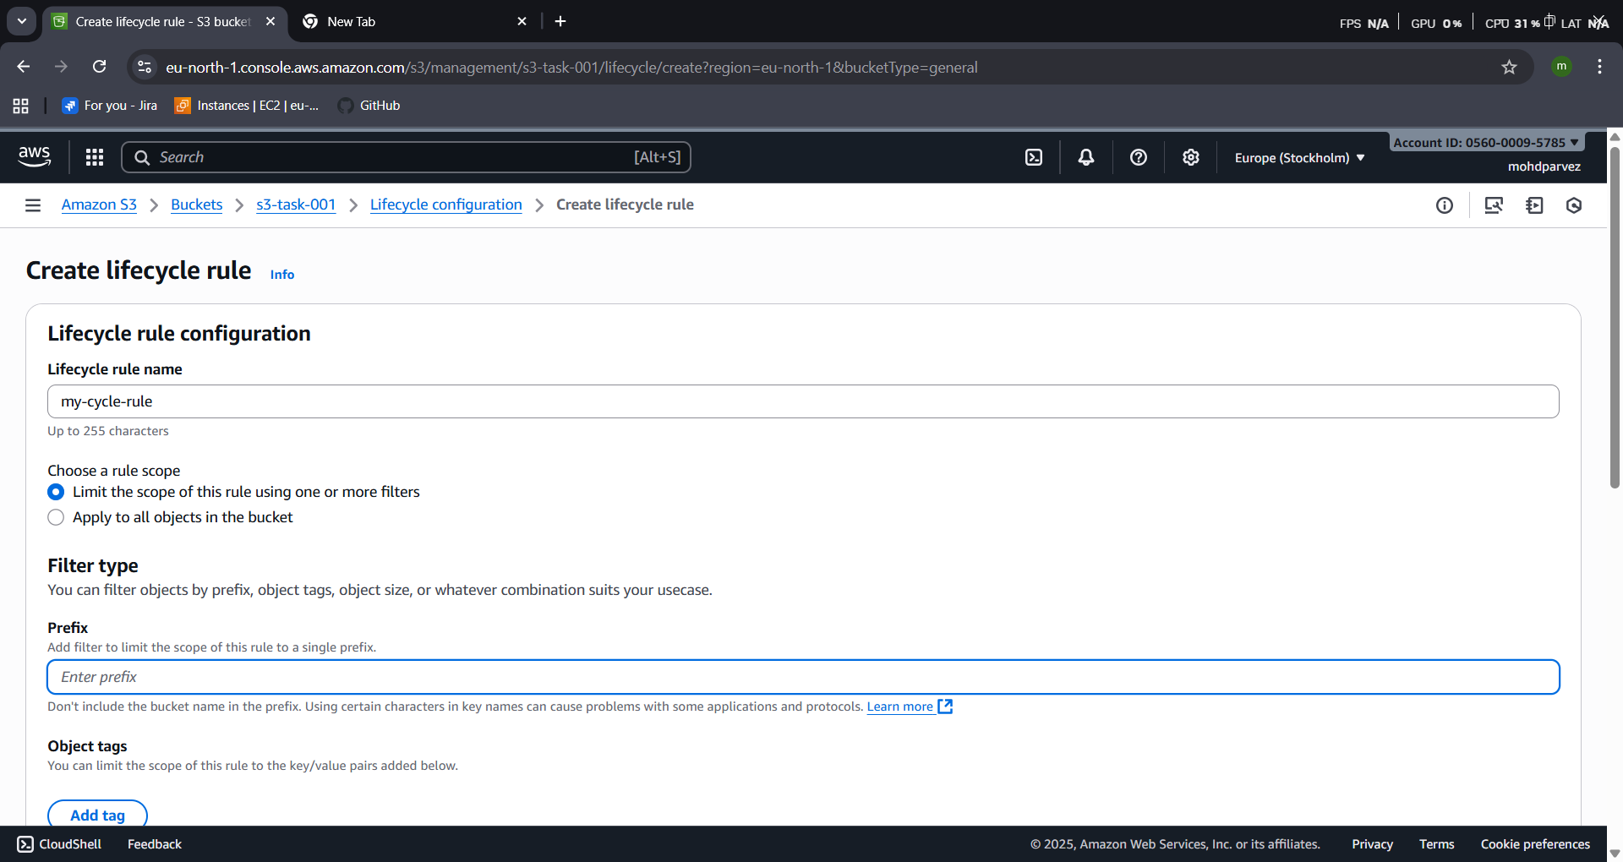
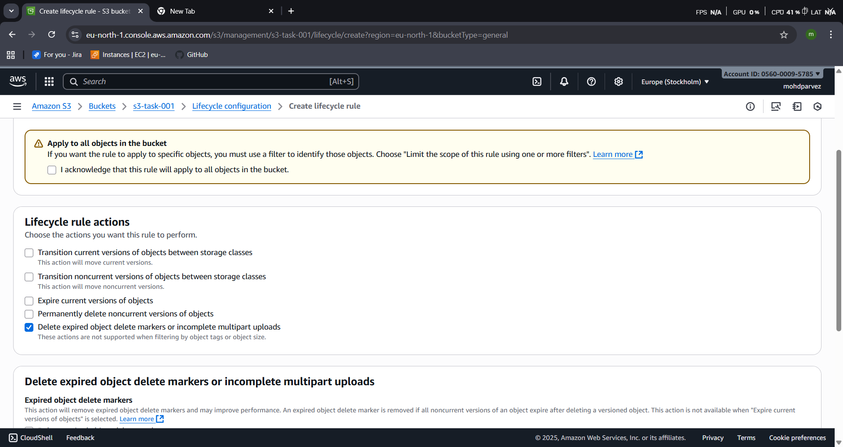
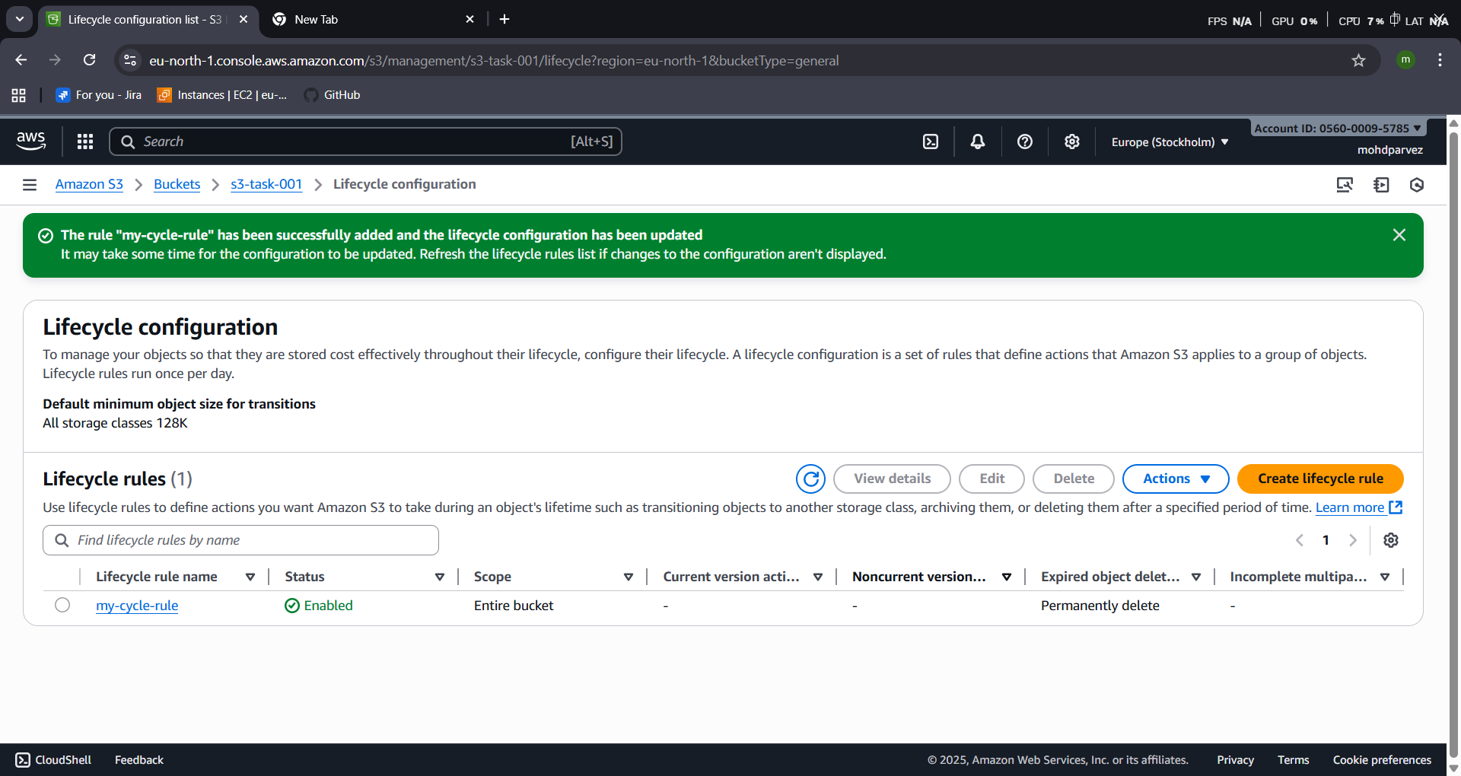

PUSH SOME OBJECTS TO S3 USING THE AWS CLI
- Connect to instance and configure Aws cli
- Aws configure
- Aws s3 ls : to check the buckets list
- aws s3 cp test.txt s3://s3-task-bucket/ : copy file to the bucket
- upload: ./test.txt to s3://s3-task-001/test.txt : you will get this output as the confirmation.

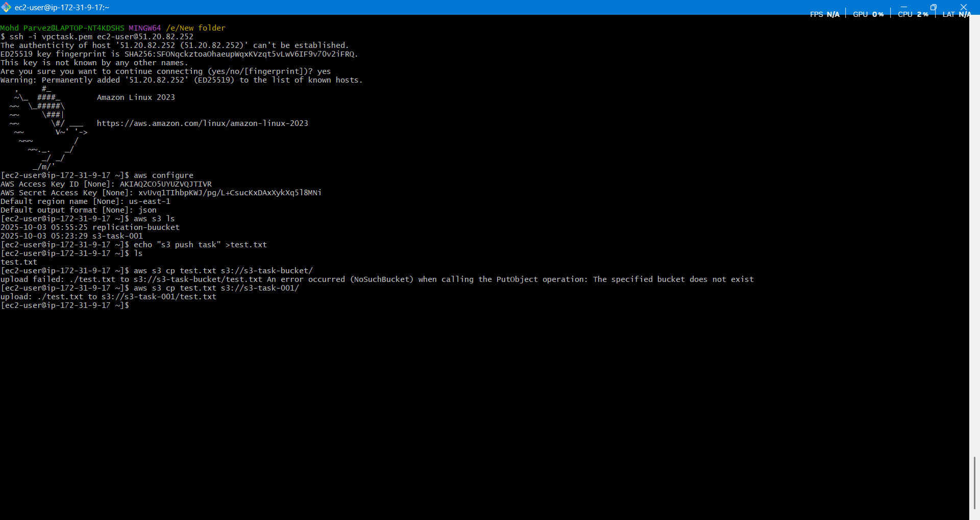
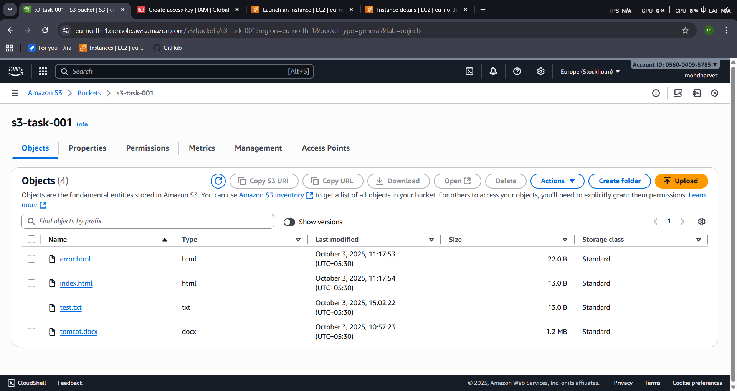

WRITE A BASH SCRIPT TO CREATE AN S3 BUCKET.
- Vi filename : create file.sh or .bash for bash script
- Write the script to create s3 bucket
#!/bin/bash

# Simple script to create an S3 bucket

# Prompt for bucket name
read -p "Enter the name of the S3 bucket: " BUCKET_NAME

# Set your preferred AWS region
REGION="us-east-1" # Change this if needed
# Create the bucket
aws s3api create-bucket \
--bucket "$BUCKET_NAME" \
--region "$REGION" \
--create-bucket-configuration LocationConstraint="$REGION"

# Check if the bucket was created successfully
if [ $? -eq 0 ]; then
echo "Bucket '$BUCKET_NAME' created successfully in region '$REGION'."
else
echo "Failed to create bucket. Please check the bucket name and region."
fi
Upload a 1 GB file to S3 using the CLI.
- Run the script : ./bucket.sh
- Give the name
- You will get the response then the bucket is created successfully
{
"Location": "http://my-bu0012.s3.amazonaws.com/"
}
Bucket 'my-bu0012' created successfully in region 'eu-north-1'.
- Go to your aws s3 you can find the bucket created with the name you provided

